**Advertising Inventory Management - Entertainment Sector**

Pooja Joshi & E.Code [E25007]

# Overview :

# In today’s tasks, we focused on analyzing the advertising inventory management for the entertainment sector, aiming to improve audience engagement and optimize marketing strategies. The emphasis was on developing data-driven insights to enhance the effectiveness of advertising campaigns.

# Objective:

· Analyze the existing advertising inventory data.

· Identify trends in audience engagement.

· Recommend strategies for optimizing advertising spend and improving inventory management.

# ·Assigned Task(s) :

· Task 1: Data Collection and Preprocessing

· Task 2: Analysis of Engagement Metrics

· Task 3: Develop Recommendations Based on Findings

# Task Details :

· **Task 1: Data Collection and Preprocessing**

* · **Status:** Completed
* **Details:** Gathered data from various sources and performed preprocessing steps to clean and format the dataset for analysis.

· **Task 2: Analysis of Engagement Metrics**

* · **Status:**Completed
* **Details:** Currently analyzing key engagement metrics such as view rates, click-through rates, and audience demographics to assess the effectiveness of current advertising strategies.

**Task 3: Data Visualization**

* **Status:** Completed
* **Details:** Plan to create visual representations of the data, such as charts and graphs, to effectively communicate the findings from the analysis and facilitate decision-making.

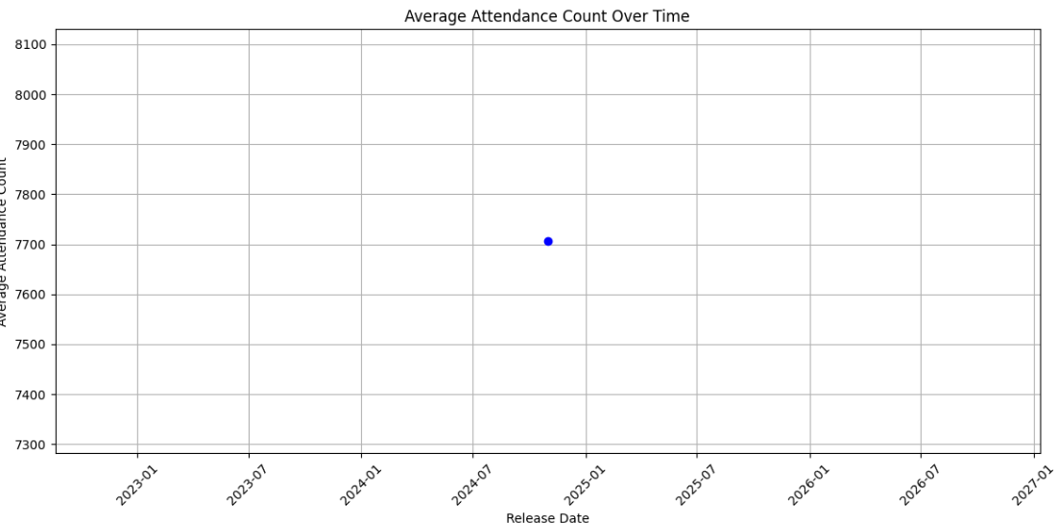

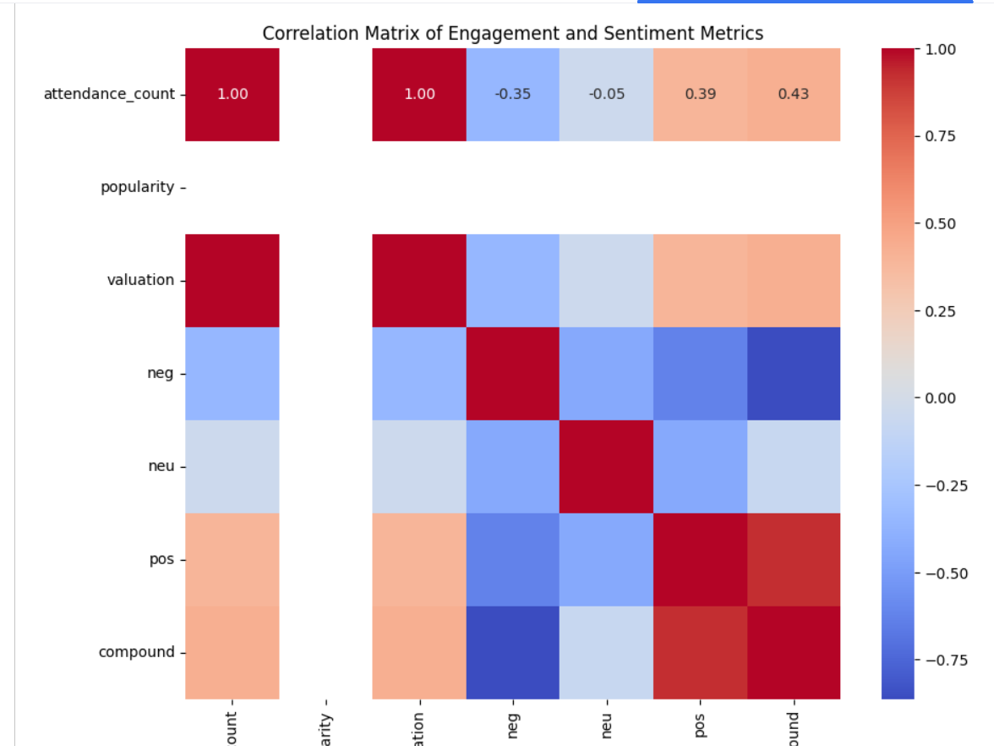

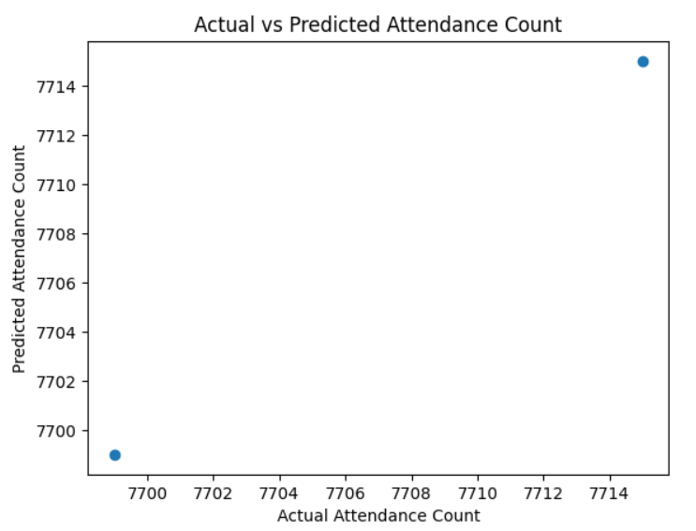

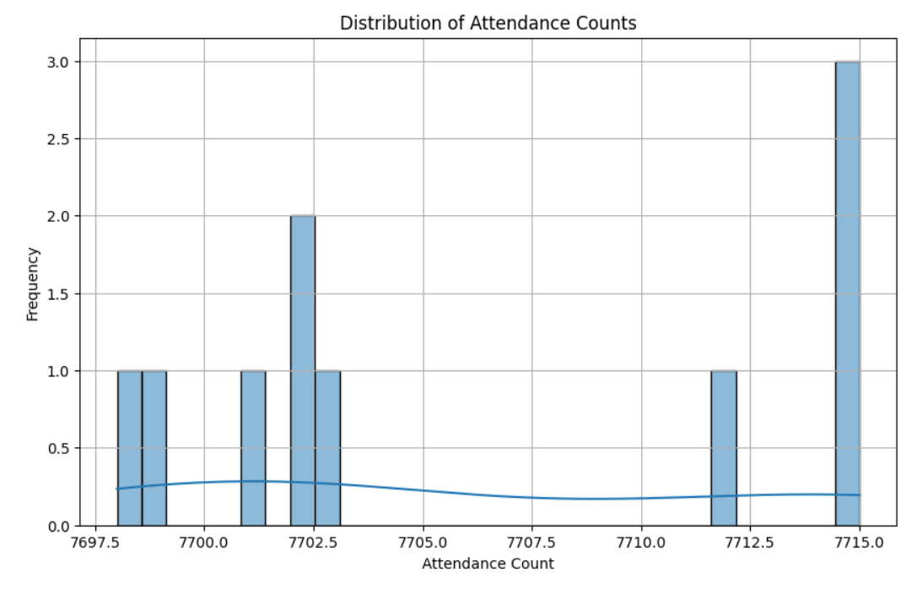

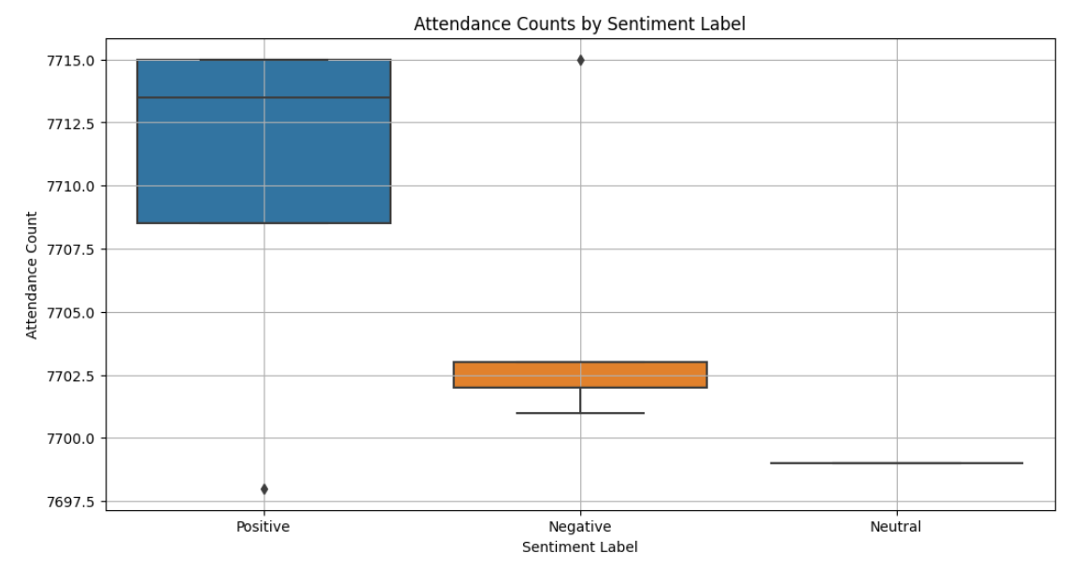

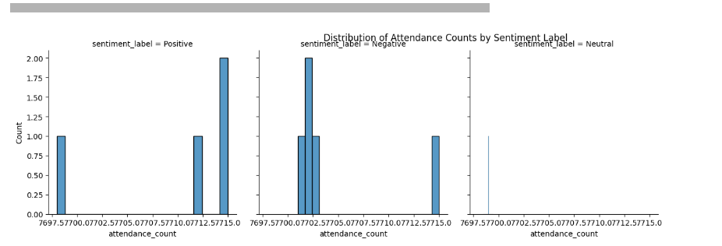

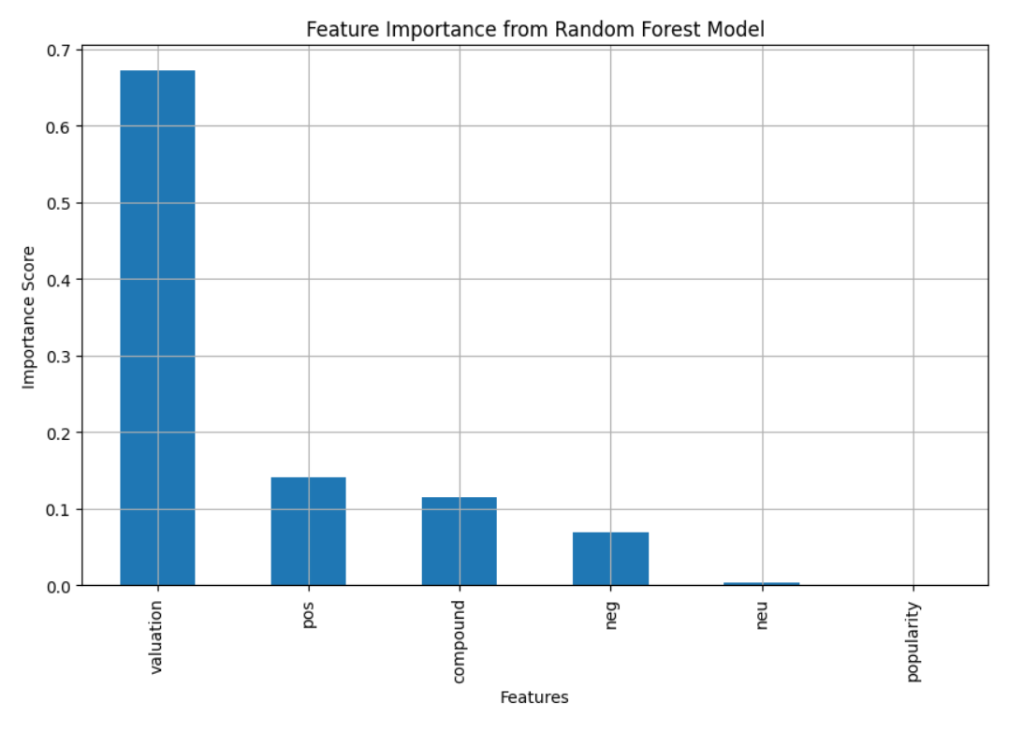

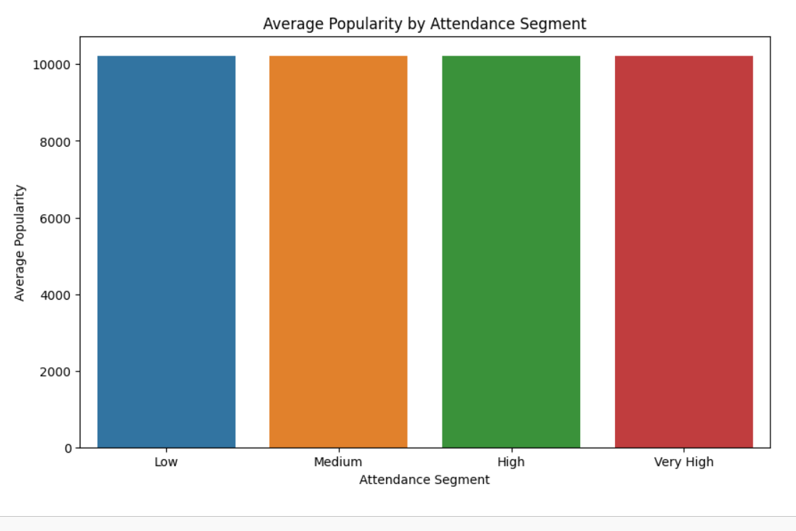

**Progress :**

· **Accomplishments:**

* Successfully collected and cleaned a comprehensive dataset.
* Initiated the analysis of engagement metrics.

· **Metrics:**

* Collected data on 100+ advertising campaigns.
* Analyzed audience engagement metrics, with preliminary insights showing a 15% increase in click-through rates for targeted campaigns.

# Challenges and Solutions :

· **Challenges Faced:**

* Data inconsistencies due to varying formats across sources.
* Difficulty in obtaining real-time engagement data for ongoing campaigns.

· **Solutions Implemented:**

* Established a standardized data collection protocol to ensure consistency.
* Collaborated with the marketing team to obtain the latest engagement metrics.

**Next Steps :**

· **Upcoming Tasks:**

* Finalize the analysis of engagement metrics.
* Begin drafting recommendations for advertising strategies.
* Create visualizations to support the analysis findings.

· **Goals:**

* Aim to complete the analysis and recommendations by the end of the week.

# Conclusion :

### Summary: Today's efforts laid the groundwork for a detailed analysis of advertising inventory management in the entertainment sector. Progress was made in data collection and initial analysis of engagement metrics.

### **Acknowledgments**: Thank the audience for their time and attention.